Lab 04

Machine Learning
Name: Syed Sualeh Abbas | Student ID: 10303

4.1 Objective
To learn and apply machine learning workflows for dataset handling, parameter tuning, script execution, and use supervised learning functions in MATLAB for training, testing, and evaluating basic models.

4.2 Introduction
This lab is designed to introduce students to fundamental machine learning concepts through a self-paced learning approach using the MATLAB Machine Learning Onramp course. Instead of a traditional step-by-step lab, students will independently engage with interactive online modules that combine short explanations, guided exercises, and instant feedback. Through this hands-on experience, students will explore core machine learning workflows in MATLAB, including data handling, model training, and evaluation, while developing practical familiarity with MATLAB Online tools. This approach encourages active learning, allowing students to progress at their own pace and build confidence in applying machine learning techniques in an engineering context.

4.3 Machine Learning
Machine learning is a subset of artificial intelligence that enables systems to learn patterns and relationships from data through algorithms rather than explicit programming. In supervised machine learning, models are trained using labeled data to perform tasks such as regression and classification. Regression models, which are the focus of this lab, aim to learn a functional relationship between input variables and continuous output values. MATLAB provides built-in tools and functions to efficiently implement and evaluate such models.
Machine learning models rely heavily on the quality of data used during training and evaluation. In real-world applications, data is rarely perfect and often contains noise, missing values, or other forms of corruption that can significantly affect model performance. Understanding how such imperfections influence learning algorithms is an essential skill for engineers and data practitioners.
The tool boxes required to perform this lab are:
- MATLAB Machine Learning Toolbox
- MATLAB Curve Fitting / Regression functions

In the upcoming task you will complete the assigned MATLAB Machine Learning online course (e.g., MATLAB Academy modules) covering topics such as:
- Introduction to Machine Learning
- Data preprocessing and visualization
- Supervised learning (classification and regression)
- Model training and validation
- Performance evaluation

Task 1: Machine Learning Onramp
To complete the mandatory task of this lab, you must first build competence. For this, complete the MATLAB Machine Learning Onramp online course and attach the completion certificate in your Live scripts.


4.4 Machine Learning Workflow
Machine learning is a structured process used to build, test, and improve machine learning models. It begins with importing and understanding data, followed by selecting or extracting relevant features. The data is then used to train a model, whose performance is evaluated using appropriate metrics. Based on the evaluation, the model is iteratively improved before being finalized for practical use.
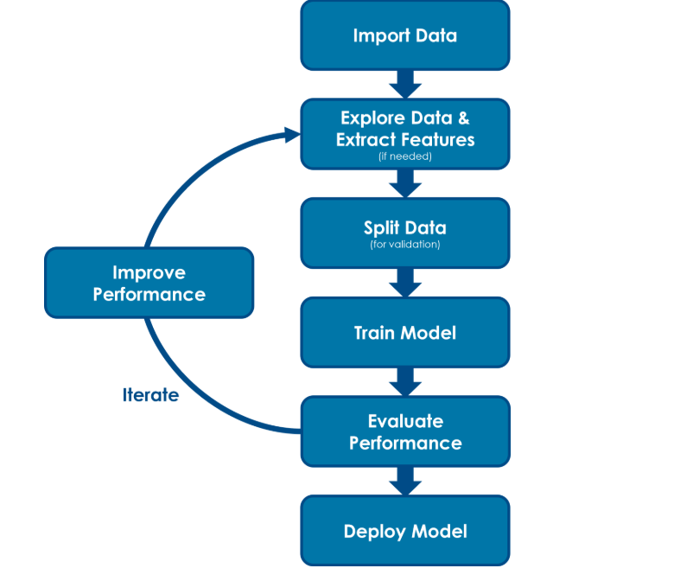
Figure 1: Machine Learning Workflow
Following are the steps of machine learning workflow:

Step 1: Import Data
The dataset is loaded into MATLAB from an external file such as a CSV or Excel sheet. This step provides the raw data required for training the machine learning model.

Step 2: Explore Data and Extract Features
The imported data is examined to understand its structure, trends, and possible issues. Relevant features are selected or extracted so that meaningful information is provided to the model.

Step 3: Split Data
The dataset is divided into training and testing subsets. The training data is used to build the model, while the testing data is used to evaluate its performance on unseen data.

Step 4: Train Model
A suitable machine learning algorithm is applied to the training data to learn the relationship between input features and output labels.

Step 5: Evaluate Performance
The trained model is tested using the test dataset. Performance is measured using metrics such as accuracy and confusion matrix to assess how well the model predicts outcomes.

Step 6: Improve Performance (Iteration)
Based on evaluation results, the model can be improved by modifying features, tuning parameters, or selecting a different algorithm. These steps are repeated until acceptable performance is achieved.

Step 7: Deploy Model
Once the model performs satisfactorily, it can be used for making predictions on new, real-world data.

Task 2
In this task we will predict whether a student will Pass or Fail based on academic performance indicators using supervised learning. Download the data present in the form of .xlsx file on lms. The data set includes the following numerical features and labels:
- StudyHours
- Attendance
- AssignmentScore
- Result (Pass / Fail)

Steps:
- Extract the data present in file student_performance.xlxs in tabular form and plot study hours Vs AssignmentScore in a graph. Comment on the results obtained.
- Perform feature selection of all the numeric data fields
- Normalize the data provided.
- Now, we are going to train and split our data, the splitting is called test split.
- Train the data using Logistic Regression Model. Use the command:
model = fitclinear(XTrain,yTrain,'Learner','logistic');
- Finally, it’s time to evaluate the model using accuracy and the confusion matrix.
- Let’s now improve the performance of our model by applying 3 different training models, apply three different models like decision tree, random forest, SVM etc. and state this in your report.
- Compare and comment on the performance of your trained machine learning model using appropriate evaluation metrics. Are there any other methods for improving the model’s performance? If yes, mention any two methods and briefly explain how each method influences the model’s final decision or prediction.
PDF OF TASK 2, IS ATTACHED BELOW AFTER ASSEMENT RUBRIC
• Load the Data
The code first reads the Excel file into MATLAB. This organizes the data in a tabular form, so it’s easy to work with. The first few rows are displayed to check the data.
• Visualize the Data. Students who passed are shown in green, and students who failed are shown in red. This helps us visually understand how study hours and assignment scores relate to passing or failing.
• Feature Selection
All numeric columns (Study Hours, Attendance, Assignment Score) are selected as input features for the model. The target variable (Pass/Fail) is stored separately as labels.
• Normalize the Data
The numeric data is scaled between 0 and 1 using min-max normalization. This ensures that no feature dominates due to its scale and helps the models learn better.
• Split the Data (Test Split)
The dataset is randomly shuffled and split into 80% training data and 20% testing data. The training data is used to teach the model, and the testing data is used to check how well the model performs on new unseen data.
• Train a Logistic Regression Model
The first model trained is Logistic Regression using the function. This model predicts whether a student will pass or fail based on the input features.
• Evaluate Model Performance
The trained model predicts the test data, and its accuracy is calculated. A confusion matrix is also created to show the number of correct and incorrect predictions for Pass and Fail.
• Improve Performance with Other Models
To get better predictions, the code trains three additional models:
Decision Tree – Learns decision rules based on feature values.
Random Forest – Combines many decision trees to make more accurate predictions.
SVM (Support Vector Machine) – Finds the best boundary to separate Pass and Fail students.
The accuracy and confusion matrix for each model are calculated, and the best-performing model is identified.
• Test with a New Student
Finally, the best model is used to predict the result for a new student with given study hours, attendance, and assignment score. The prediction shows whether the student is likely to pass or fail.

Assessment Rubric
Lab 04
Lab 4: Machine Learning

Name: | Student ID:

Marks distribution:
 | Tasks | LR2  Code | LR5  Results | AR4  Report Submission | AR7  Comments
In-Lab | Task 1 |  | /50 | /5
In-Lab | Task 2 | /20 | /20 | /5 | /5
Total =100 |  | /20 | /70 | /5 | /5
CLO Mapped |  | CLO1 | CLO1 | CLO3 | CLO1

CLO | Total Points | Points Obtained
1 | 95
3 | 5
Total | 100

For description of different levels of the mapped rubrics, please refer the provided Lab Evaluation Assessment Rubrics and Affective Domain Assessment Rubrics.

Lab Evaluation Assessment Rubric
# | Assessment Elements | Level 1: Unsatisfactory  Points 0-1 | Level 2: Developing  Points 2 | Level 3:Good  Points 3 | Level 4:Exemplary  Points 4
LR2 | Program/Code/ Simulation Model/ Network Model | Program/code/simulation model/network model does not implement the required functionality and has several errors. The student is not able to utilize even the basic tools of the software. | Program/code/simulation model/network model has some errors and does not produce completely accurate results. Student has limited command on the basic tools of the software. | Program/code/simulation model/network model gives correct output but not efficiently implemented or implemented by computationally complex routine. | Program/code/simulation /network model is efficiently implemented and gives correct output. Student has full command on the basic tools of the software.
LR3 | Troubleshooting | Unable to identify the fault/minimal effort show in troubleshooting. | Able to identify the fault but unable to remove it. | Able to identify the fault but partially removes it. | Able to identify the fault and takes necessary steps and actions to correct it.
LR4 | Data Collection | Measurements are incomplete, inaccurate and imprecise. Observations are incomplete or not included. Symbols, units and significant figures are not included. | Measurements are somewhat inaccurate and imprecise. Observations are incomplete or vague. Major errors are there in using symbols, units and significant digits. | Measurements are mostly accurate. Observations are generally complete. Minor errors are present in using symbols, units and significant digits. | Measurements are both accurate and precise. Data collection is systematic. Observations are very thorough and include appropriate symbols, units and significant digits and task completed in due time.
LR5 | Results & Plots | Figures/ graphs / tables are not developed or are poorly constructed with erroneous results. Titles, captions, units are not mentioned. Data is presented in an obscure manner. | Figures, graphs and tables are drawn but contain errors. Titles, captions, units are not accurate. Data presentation is not too clear. | All figures, graphs, tables are correctly drawn but contain minor errors or some of the details are missing. | Figures / graphs / tables are correctly drawn and appropriate titles/captions and proper units are mentioned. Data presentation is systematic.
LR6 | Calculations | Formulae used and/or calculations are incorrect. Units are not mentioned with results. | Formulae used are correct but there are few mistakes in calculation which lead to incorrect results. | Formulae used and end results are correct. Complete working steps are not shown. Proper units are not mentioned with results. | Formulae used, end results and all calculations are correct with all the intermediate steps clearly shown. Units are mentioned with results.
LR9 | Report | All the in-lab tasks are not included in report and / or the report is submitted too late. | Most of the tasks are included in report but are not well explained. All the necessary figures / plots are not included. Report is submitted after due date. | Good summary of most the in-lab tasks is included in report. The work is supported by figures and plots with explanations. The report is submitted timely. | Detailed summary of the in-lab tasks is provided. All tasks are included and explained well. Data is presented clearly including all the necessary figures, plots and tables.
LR11 | Design | Proposed design is unsubstantiated or does not satisfy most of given constraints. The breakdown of system into features is incomplete and still at lower resolution. | Justification for proposed design is weak, and it only satisfies some constraints. The breakdown of system is missing some features and resolution is not appropriate at some places. | Proposed design is substantiated, preferably through proper analysis, and satisfies most given constraints. The breakdown of system into features seems complete, but resolution is not appropriate at some places. | Proposed design is substantiated, preferably through proper analysis, and satisfies all given constraints. The breakdown of system into features seems complete and at appropriate resolution, given students' level.
AR4 | *Report Submission | Not accepted after 1 week. | Late submission after 2 days and within 1 week. | Late submission after the lab timing and within 2 days of the due date. | Timely submission of the report and in the lab time.
AR7 | Report Content/Code comments | Most of the questions are not answered / figures are not labelled/ titles are not mentioned / units are not mentioned. No comments are present in the code. | Some of the questions are answered, figures are labelled, titles are mentioned and units are mentioned. Few comments are stated in the code. | Majority of the questions are answered, figures are labelled, titles are mentioned and units are mentioned. Comments are stated in the code. | All the questions are answered, figures are labelled, titles are mentioned and units are properly mentioned. Proper comments are stated in the code.

